|  |
| --- |
| **User Guide for Computing Accessibility** |

|  |
| --- |
| Revision Date  2020-3-31 |

**CONTACT INFORMATION**

Further Details in https://github.com/xzhou99

For more information, please contact:

Xuesong Zhou ([xzhou74@asu.edu](mailto:xzhou74@asu.edu))

**TABLE OF CONTENTS**

1. GETTING STARTED 1

1.1 What is GMNS? 1

1.2 What is AMS? 1

1.3 What is NEXTA? 1

2. DATA FILE DESCRIPTION 2

2.1 GMNS Network Files 2

2.2 AMS Files 5

3. USER INTERFACES & BASIC CONTROLS 6

3.1 User Interfaces 6

3.1.1. Layer Control Panel 6

3.1.2. Attribute Data Display Panel 7

3.2 Management Toolbar 8

3.2.1. Basic Management Tools 8

3.2.2. Network Editing Tools 9

3.2.3. Clock Controlling Tools 10

3.3 Viewing Modes 11

3.3.1. Network View 11

3.3.2. Animation View 12

3.4 MOE Toolbar 12

3.4.1. Density Visualization 13

3.4.2. Volume Visualization 13

3.4.3. Velocity Visualization 14

3.4.4. Queue Visualization 15

3.4.5. Bottleneck Visualization 15

3.5 Detailed Analytical Tools 16

3.5.1. Link Analysis Tool 16

3.5.2. Path Analysis Tool 17

3.5.3. Agent Analysis Tool 18

3.5.4. Summary Analysis Tool 22

# GETTING STARTED

**Network data structure** defines the basic node-link structure, along with attributes for each link and node. Additionally, nodes are related to movement, which can be used to disaggregate trips from nodes to nodes.

Below is a short list of key features for GMNS data files and simple AMS data structure.

|  |  |
| --- | --- |
| **File Name** | |
| A: GMMS Network Files | A1: node.csv |
| A2: road_link.csv |
|  |
| B: Model Input | B1: link_type.csv  B2: agent_type.csv |
| B3: input_agent.csv |
| C: Model output | C1: [output_accessibility.csv](https://docs.google.com/spreadsheets/d/1Jrmq3tlV22qrwJb4tzHivMio04DNHZwHqdlJOcE_oIc/edit" \l "gid=689476001) |
|  | C2: output_summary.csv |

# DATA FILE DESCRIPTION

### 2.1 GMNS Network Files

High-level introductions:

* A generic network used for GMNS readable by NeXTA includes a set of three layers: node, link and movement.
* The specific file names are node.csv and road_link.csv.
* A link is defined using upstream node and downstream node ids, with essential attributes such as length to calculate shortest path distance, typically required for accessibility computation. You can understand this distance is the general cost value, and one can use equivalent travel time in this field to perform the computation.
* The node and link layers can use arbitrary coordinate system, but a WKT (lon/lat) coordinate system is preferred.

#### 1. node.csv

|  |  |  |
| --- | --- | --- |
| **Field Name** | **Description** | **Sample Value** |
| name | Optional for visualization only | Main street @ Highland Dr. |
| node_id | Node identification number | 1001 |
| ctrl_type | Optional intersection control type | 5 |
| node_type | Optional text label for visualization and identifies of node | 1 |
| x_coord | Longitude or horizontal coordinate in any arbitrary geographic coordinate system. | 100 |
| y_coord | Latitude or vertical coordinate horizontal coordinate in any arbitrary geographic coordinate system | 200 |
| geometry | Text string used to describe node location <https://en.wikipedia.org/wiki/Well-known_text_representation_of_geometry> | POINT (30 10) |

**Remarks:**

#### 2. road_link.csv

|  |  |  |
| --- | --- | --- |
| **Field Name** | **Description** | **Sample Values** |
| name | Optional for visualization purposes | Main Street |
| road_link_id | Link identification number of the road | 101 |
| from_node_id | Upstream node number of the link, must already defined in input_node.csv | 2 |
| to_node_id | Downstream node number of the link, must already defined in input_node.csv | 3 |
| link_type | Optional text label for visualization and data checking purposes | 1 |
| length | The length of the link (between end nodes), measured in units of miles. | 1.0 |
| lanes | The number of lanes on the link | 2 |
| dir_flag | 0: two-way link, 1: one-way link | 1 |
| capacity | The number of vehicles per hour per lane. | 1500 |
| geometry | Text string used to describe link shape and location (typically in WKT geographic coordinate system). The initial value can be empty, and NeXTA will generate the text string based on the coordinates of upstream and downstream nodes. | LINESTRING (30 10, 10 30, 40 40) |

**Remarks:**

**Fields can be generated or populated by NeXTA:**

geometry fields can be imported from GIS shape files or generated based on the coordinates of upstream and downstream nodes. dir_flag= 1 by default.

### 2.2 AMS Files

High-level introductions:

* The specific file names are agent.csv, link_performance.csv.
* The agent file contains the specific information of each agent in the simulation network, such as, agent id, demand type, time period and so on.
* The link performance file contains the each link’s information, such as, time period, travel time and some notes.

#### 1. input_od_pairs.csv

|  |  |  |
| --- | --- | --- |
| **Field Name** | **Description** | **Sample Value** |
| agent_id | Agent identification number | 1 |
| o_node_id | Origin node number of the agent | 1 |
| d_node_id | Destination node number of the agent | 20 |

#### 2. output_accessibility.csv

|  |  |  |
| --- | --- | --- |
| **Field Name** | **Description** | **Sample Value** |
| agent_id | Agent identification number | 1 |
| o_node_id | Origin node number of the agent | 1 |
| d_node_id | Destination node number of the agent | 20 |
| distance | Distance of shortest path | 20 |

# USER INTERFACES & BASIC CONTROLS

## User Interfaces

### Layer Control Panel

NeXTA’s user interface uses layer controls which are similar to those used in common GIS software applications to manage which network object types are displayed/selected.

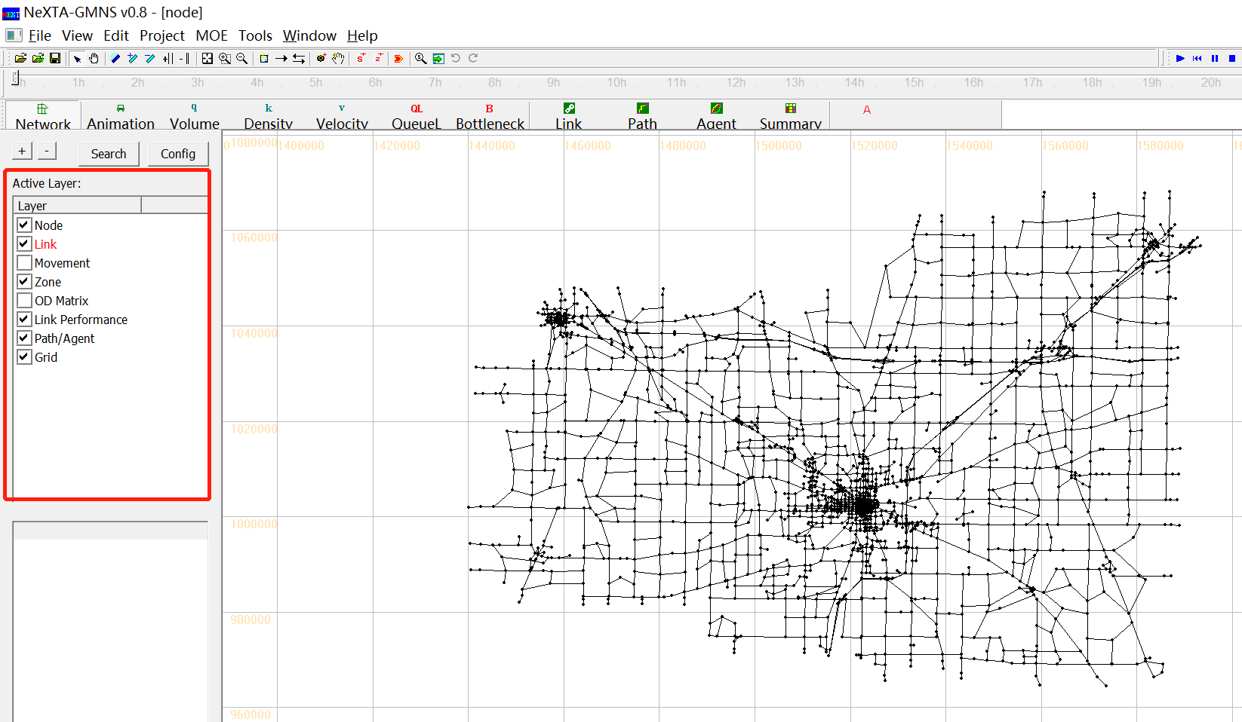

The list of layers at the left side of the screen, highlighted in the figure above, is used to control what is visible in the display. The panel display controls the Node, Link, Movement, Zone, OD Matrix, Link Performance, Path/Agent, Grid. Each layer refers to a different type of network data, which is stored in the network input/output files in the project folder.

**The box alongside each layer’s text label** is used to control the layer’s visibility. An empty box indicates that the layer is not visible, and a check mark in the box indicates that the layer is visible (if data is available for display). In some cases, after turning a layer on or off, the user may need to click the layer’s text label to refresh the display for that specific layer.

**The layer text label** is used to control which objects can be selected in the network. In particular, the selectable layers are limited to the layers such as Node, Link, Movement, Zone and OD Matrix. With the layer turned on (enabled), left-clicking on the layer text label enables selection using the Select Object tool. The text label is highlighted in red text after selection, indicating which network object type can be selected using the Select Object tool. Please see more detail illustration for examples for using this functionality.

### Attribute Data Display Panel

The lower half of the panel at the left side of the screen shows attribute data for a selected object, as shown in the figure below. The information displayed in this section of the panel is dependent upon the selected network object type.

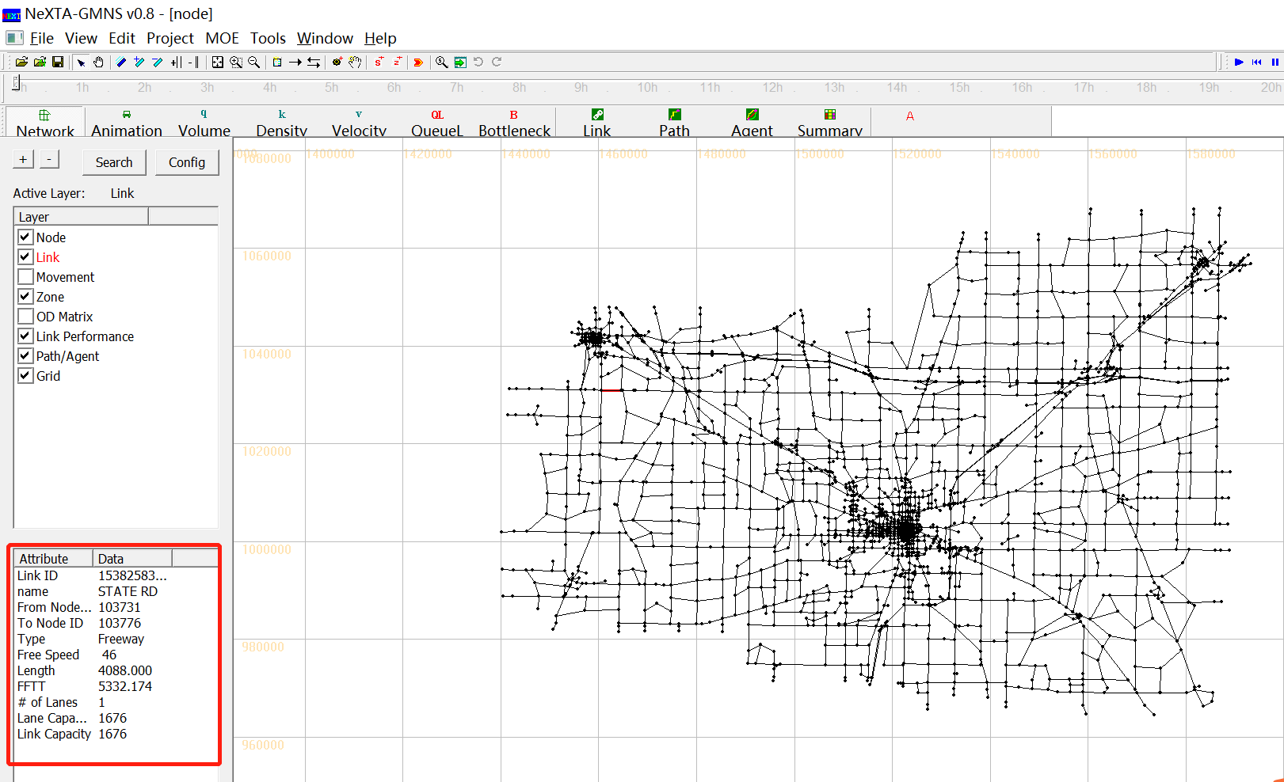

Node attribute data displayed in the panel includes the node ID number, control type, geographic coordinates, and associated zone ID number (=corresponding zone number, if a node is an activity location; =0, otherwise) for the selected node. Link attribute data displayed in the panel includes the link ID number, link name, starting node ID number, ending node ID number, link type, speed limit, length, free-flow travel time, number of lanes, lane capacity and link capacity for the selected link. An example is shown in the figure below with link attribute data.

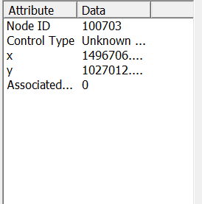 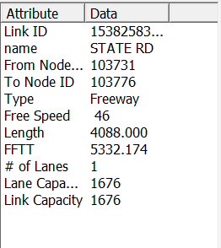

## Management Toolbar

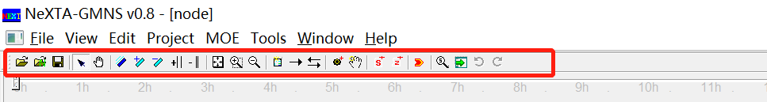

### Basic Management Tools

|  |  |  |
| --- | --- | --- |
| **Icon** | **Name** | **Function** |
|  | Open Project |  |
|  | Open New Project |  |
|  | Save Project | Save network to given path/file name |
|  | Select Object | Select a node/link/zone |
|  | Move Network |  |
|  | Switch Link Bar/Line Display Mode |  |
|  | Increase Link Bandwidth |  |
|  | Decrease Link Bandwidth |  |
|  | Increase Link Offset |  |
|  | Decrease Link Offset |  |
|  | Show Network | Show entire network |
|  | Zoom In |  |
|  | Zoom Out |  |
|  | Search Node/ Link/Path/Vehicle | Opens a dialog box which enables search functionality in NeXTA. Search by node number to find nodes, links (from node and to node notation), paths (from node and to node notation, using shortest path), and vehicle number (when simulations results are available). |
|  | Visit Development Website |  |
|  | Run Simulation |  |

### Network Editing Tools

|  |  |  |
| --- | --- | --- |
| **Icon** | **Name** | **Function** |
|  | Set Default Link Type | Opens a dialog box displaying the default link properties for different link types. The user may select and edit the default link properties so that all new links created afterward are assigned those changes. |
|  | Add New One-Way Links | Create a new one-way, directional link between two nodes. |
|  | Add New Two-Way Links | Create two one-way, directional links between two nodes. |
|  | Add New Node | Create a new node to which links can be attached. |
|  | Move Node Position |  |
|  | Create Subarea for subarea Analysis | Create a subarea boundary which is used to perform a subarea cut (see Subarea Analysis for more details). |
|  | Create New Zone | Create a new zone |

### Clock Controlling Tools

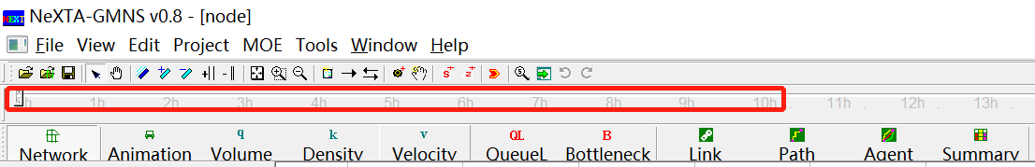

**The Clock Bar**(highlighted in the figure above) is a toolbar feature located at the top of the screen which allows the user to view time-dependent MOEs by controlling the position of the slider on the toolbar. As shown above, the toolbar is divided into hours so that the position of the slider refers to the time within a 24-hour modeling time horizon.



The buttons at the right above the Clock Bar are used for controlling the progression of time. This can also be accomplished by using the mouse to move the slider, clicking and dragging the slider to the desired location (time) on the bar.

|  |  |  |
| --- | --- | --- |
| **Icon** | **Name** | **Function** |
|  | Star Animation (Min by Min) | Progresses forward automatically through time in 1 minute steps |
|  | Rewind | Rewind the time back to 00:00 |
|  | Pause Animation | Temporarily stops the automatic progression of time until the play button is pressed again |
|  | Stop Animation | Stops the automatic progression of time and reset the time back to 00:00 |
|  | Play Forward 1 Min | Moves forward in time by 1 minute |
|  | Skin Forward 5 Min | Moves forward in time by 5 minutes from the current time |
|  | Play Backward 1 Min | Moves backward in time by 1 minute |
|  | Skin Backward 5 Min | Moves backward in time by 5 minutes from the current time |
|  | Play Forward 1 Sec | Moves forward in time by 1 second |
|  | Play Backward 1 Sec | Moves backward in time by 1second |
|  | Star Animation (Sec by Sec) | Progresses forward automatically through time in 1 second steps |
|  | Show/Hide Legend | Toggles legend visibility |

## Viewing Modes



Two different viewing modes are available in NeXTA - Network View mode and Animation View mode. The default Network View mode is used to display Measures of Effectiveness (MOEs) and the network geometry, while the Animation View is used to show individual vehicles moving in the network during simulation. The user can use the and  buttons on the MOE Toolbar to control which view is used.

### Network View

In the default visualization state, each link is shown with a line width to represent the number of lanes. Additionally, many MOE visualization features use the link width to visually show how MOEs change over time or differ from one link to another. The  button on the MOE Toolbar changes this visualization state so that no links in the network will be shown with a link width.

